

Project Initialization and Planning Phase
Date | 30 June 2026
Team ID
Project Name | Smart Lender
Maximum Marks | 3 Marks
Define Problem Statements (Customer Problem Statement Template): 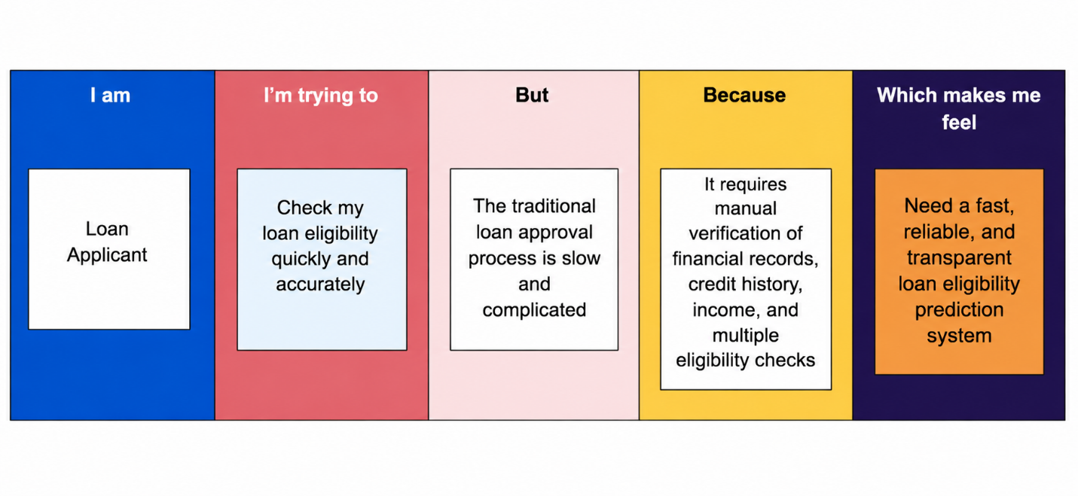
Problem  Statement  (PS) | I am  (Customer) | I’m trying to | But | Because | Which makes me  feel
PS-1 | Loan Applicant | Check my loan eligibility quickly and accurately | The traditional loan approval process is slow and complicated | It requires manual verification of financial records, credit history, income, and multiple eligibility checks | Need a fast, reliable, and transparent loan eligibility prediction system

